**A**

**MINOR PROJECT REPORT**

**on**

**CONNECTPLAY**

**BE(AI&DS) -V Sem**

**By**

**Sadhvik Reddy Vutkur (160120771046)**

**Sai Sathvik Vadari (160120771048)**

**Srinivas Patnaik Balivada (160120771055)**

**Under the guidance of**

**Ms. A. Srilakshmi**

**Associate Professor**

**IT Department**



**DEPARTMENT OF INFORMATION TECHNOLOGY   
CHAITANYA BHARATHI INSTITUTE OF TECHNOLOGY (A)**

**(Affiliated to Osmania University; Accredited by NBA(AICTE) and NAAC(UGC), ISO Certified 9001:2015)**

**KOKAPET(V), GANDIPET(M), RR District HYDERABAD - 75**

**Website:** [**www.cbit.ac.in**](http://www.cbit.ac.in/)

**2021-2022**



This is to certify that the project work entitled “**CONNECTPLAY**” submitted to CHAITANYA BHARATHI INSTITUTE OF TECHNOLOGY, in fulfillment of the requirements for the completion of Minor Project-I of  V Semester B.E. in Artificial Intelligence and Data Science, during the Academic Year 2022, is a record of original work done by **Sadhvik Reddy Vutkur (160120747046), Sai Sathvik Vadari (160120747048), Srinivas Patnaik Balivada (160120771055)** during the period of study in the Department of IT, CBIT, HYDERABAD, under our guidance.

|  |  |
| --- | --- |
| **Project Guide** | **Head of the Department** |
| **Ms. A. Srilakshmi** | **Dr.K. Radhika** |
| Associate Professor, Dept. of IT, | Professor, Dept. of IT, |
| CBIT, Hyderabad. | CBIT, Hyderabad. |

## ACKNOWLEDGEMENTS

We would like to express our heartfelt gratitude to **Ms. A. Srilakshmi,** our project guide, for her invaluable guidance and constant support, along with her capable instruction and persistent encouragement.

We are grateful to our Head of Department, **Dr. K. Radhika**, for her steady support and for the provision of every resource required for the completion of this project.

We would like to take this opportunity to thank our Principal, **Dr. P. Ravinder Reddy**, as well as the Management of the Institute, for having designed an excellent learning atmosphere.

Our thanks are due to all members of the staff and our lab assistants for providing us with the help required to carry out the groundwork of this project.

**CONTENTS**

|  |  |  |
| --- | --- | --- |
| **S. No** | **Topics** | **Page. No** |
|  | **List of Figures** | v |
|  | **List of Tables** | vi |
|  | **Abbreviations** | vi |
|  | **Abstract** | vii |
| 1 | **Introduction** |  |
| * 1. Motivation | 1 |
| * 1. Objective of the Project | 1 |
| 1.3 Problem Statement | 1 |
| 2 | **Existing System** |  |
| 2.1 Literature survey | 2 |
| 3 | **Proposed Methodology** |  |
| 3.1 System Specifications | 3 |
| 3.2 System Design | 5 |
| 3.3 Proposed Work | 6 |
| 4 | **Implementation and Results** | 7 |
| 5 | **Conclusion and Future Scope** | 13 |
| 6 | **Bibliography** | 14 |

## 

**List of Figures**

|  |  |  |
| --- | --- | --- |
| **Figure No** | **Name of the Figure** | **Page No** |
| **1** | **Graph** | **2** |
| **2** | **System Design (admin)** | **5** |
| **3** | **System Design (player)** | **5** |
| **4** | **Website Screenshots** | **7** |
| **5** | **Website Screenshots** | **7** |
| **6** | **Website Screenshots** | **8** |
| **7** | **Website Screenshots** | **8** |
| **8** | **Website Screenshots** | **9** |
| **9** | **Website Screenshots** | **9** |
| **10** | **Website Screenshots** | **10** |
| **11** | **Website Screenshots** | **10** |
| **12** | **Website Screenshots** | **11** |
| **13** | **Website Screenshots** | **11** |

**List of Tables**

|  |  |  |
| --- | --- | --- |
| **Table No** | **Name of the Table** | **Page No** |
|  |  |  |
|  |  |  |
|  |  |  |
|  |  |  |
|  |  |  |
|  |  |  |
|  |  |  |
|  |  |  |
|  |  |  |
|  |  |  |
|  |  |  |

**\*No tables have been used**

**List of Abbreviations**

|  |  |
| --- | --- |
| **Acronym** | **Abbreviation** |
| **HTML** | **Hypertext Markup Language** |
| **CSS** | **Cascading Style Sheets** |
| **RAM** | **Random Access Memory** |
| **JS** | **Java Script** |
| **MBPS** | **Mega Bytes per Second** |
| **SQL** | **Sequential Query Language** |
| **MERN** | **MongoDB Express JS React JS Node JS** |
| **DB** | **Database** |
|  |  |
|  |  |
|  |  |

**ABSTRACT**

“Life is more fun if you play games.” – Roald Dahl. Games play an essential role in all our lives. We play games not just for entertainment but also to keep the body and mind sharp. In this vast world of multiplayer sports and games, to have a strong team is the primary objective. We have observed that many people stop playing a team sport due to the lack of players. The motto of this website is to develop a platform to connect the players to the game.

This way an individual who wants to play a sport can join a pre-existing team who require players, providing a better experience for everyone in that sport. It will pave way to a great environment to make new friendships. Our open for all website also decided to offer slot booking feature for online gaming centers. Many who do not have expensive gaming hardware can always spend some time relaxing by booking a slot in the gaming center closest to their home and play a game of their choice.

Our website will have 2 interfaces: Admin (to add and edit games) and Player (to book slots and avail features). There will be a sophisticated login page dedicated to each type of the user. The entire project will be developed using MERN technology stack. The data will be stored in Mongo DB. From this website we hope to connect various players to teams to make everyone’s game better.

**1. INTRODUCTION**

**1.1 Motivation**

* After the COVID-19 Pandemic, there has been a dip in the interest in team sports in many children aged 6-17.
* According to the research by *Utah State University in 2021*, an estimated 27.8 % youth have lost interest in organized sports post pandemic.
* We created this project to rekindle the spirit in the youth and bring back the joy and benefits of playing team sports with friends and family.
* A **platform-based** website to connect the players to the game.
  1. **Objective of the Project**
* The main objective of this project is to connect individuals to various team sports of their choice to create a fulfilled game experience.
* The other objectives of this project are to build a platform-based website that will also encourage students to explore more about careers and interests in E-Sports with the online game booking availability.
* Through the development of this project, we also aimed at learning some technical skills such as MERN stack and Redux which are the current stacks used in the industry as of this day.
  1. **Problem Statement**
* People have fallen into their busy schedules and have forgotten the importance of physical activities. Games and sports provide both physical and mental fitness.
* How to make sports accessible to all? Such that everyone can connect with each other to build better relationships as well as improve team-building mentality.

**2. EXISTING SYSTEM**

**2.1 Literature Survey**

* One of our main inspirations for this project has been the post COVID impact on may team sports. Many children have completely stopped playing team sports and the gradual decrease is imminent as shown in the graph below.
* Many educational institutions are trying to bring back the culture of playing sports as it is proven that it not only reduces lethargy in growing kids but also has many cognitive effects.
* This statistic perennially shows a decline. In 2020, only 25 percent of kids regularly participated in high-calorie-burning sports. The figure was as high as 45 percent in 2008.
* Using these Statistics, we thought it would be a great way to remind everyone the spirit of the game and bring back new friendships that can be made on the field (online or offline).
* This way we are providing a technological driven solution to make sure no one is playing a team sport without full capacity.
* Currently there is no existing system on this topic while many institutions are trying to counsel kids the importance of games by showing them various statistics.

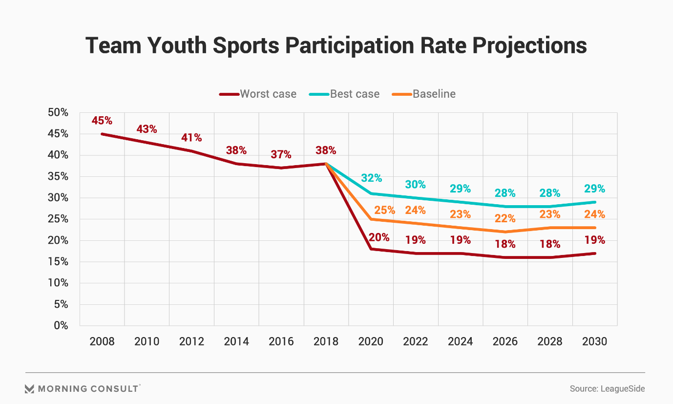

**3. PROPOSED METHODOLOGY**

**3.1 System Specifications**

Software Requirements

* Operating system: Windows7/8/10/11

Tools:

* Preinstalled Visual Studio Code (version 1.63.2)
* Preinstalled Browser like Google chrome/Mozilla Firefox/Microsoft Edge
* Live Server in Visual Studio Code
* Code runner Extension in Visual Studio Code
* Java Script Debugger

Front end:

* HTML: It is the code that is used to structure a web page and its contents.
* CSS: It is a style sheet used for describing the presentation of a document written in a markup language such as HTML. It creates an attractive layout.
* Boot Strap: Boot Strap is the most popular HTML, CSS and JavaScript framework for developing a responsive and mobile friendly website. It is a front-end framework used for easier and faster web development. It also supports Java Script Plug-ins.
* JavaScript: JavaScript is a text-based programming language used both on the client-side and server-side that allows us to make web pages interactive. It creates a dynamic and interactive experience for the user.
* React JS: React is a free and open-source front-end JavaScript library for building user interfaces based on UI components. It is maintained by Meta and a community of individual developers and companies.

Back end:

* MongoDB: MongoDB is a source-available cross-platform document-oriented database program. Classified as a NoSQL database program, MongoDB uses JSON-like documents with optional schemas. MongoDB is developed by MongoDB Inc. and licensed under the Server Side Public License which is deemed non-free by several distributions.
* Node.js: Node.js is an open- source, cross-platform, back-end Java Script runtime environment that runs on the V8 Engine and executes JavaScript code outside a web browser, which was designed to build scalable network applications. Node.js lets developers use JavaScript to write command line tools and for server-side scripting - running scripts server-side to produce dynamic web page content before the page is sent to the user's web browser.

Hardware Requirements

* Processor: Any Quad-Core or Octa-Core
* Processor Speed: Any
* RAM: 2GB or above
* Hard Disk: Any
* Stable internet connection: 2 MBPS or above

**3.2 System Design**

**3.2.1 System Design (Admin)**

**3.2.2 System Design (Player)**

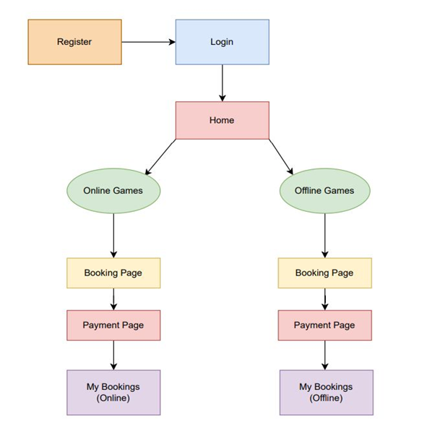

**3.3 Proposed Work**

* Selection of Idea
* Preparation of Abstract
* Learning MVC framework and planning of project accordingly
* Learning MongoDB and configuring the backend
* Implementation of HTML and CSS to make multiple webpages and design them
* Used react to make the static pages into dynamic pages with interactive UI
* Learning Express JS and implementing it
* Implementation of Java script for various frontend functions
* Final Testing of website and its features followed by debugging

**4. IMPLEMENTATION AND RESULTS**

Login Page:

This page is shown first asking user to login.

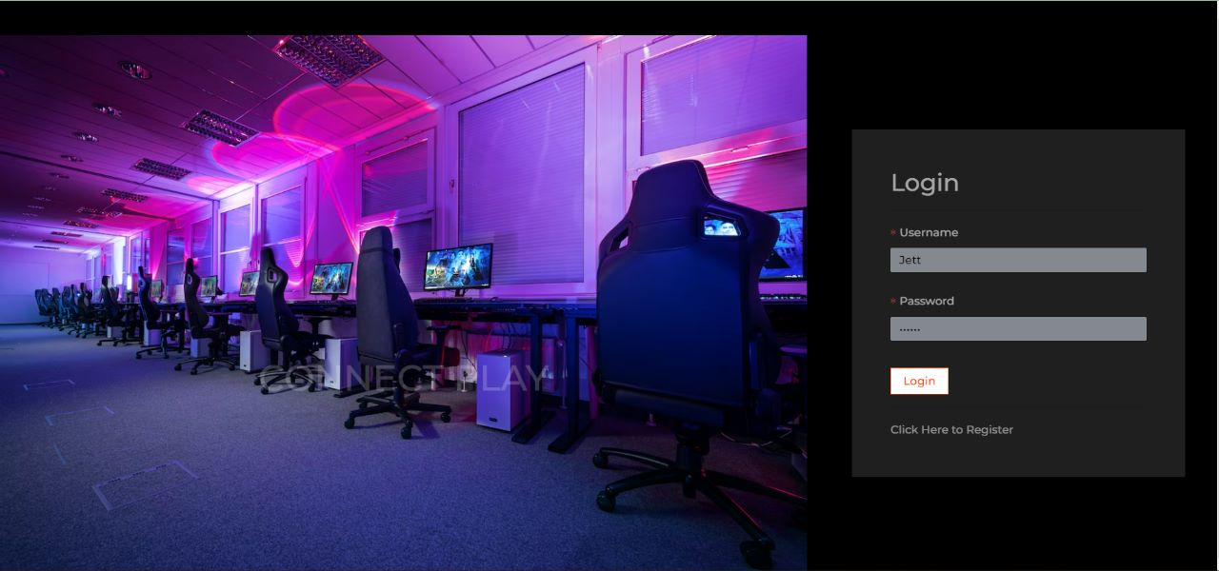

Register Page:

This Page can be located from the login page if the user is new to our website.

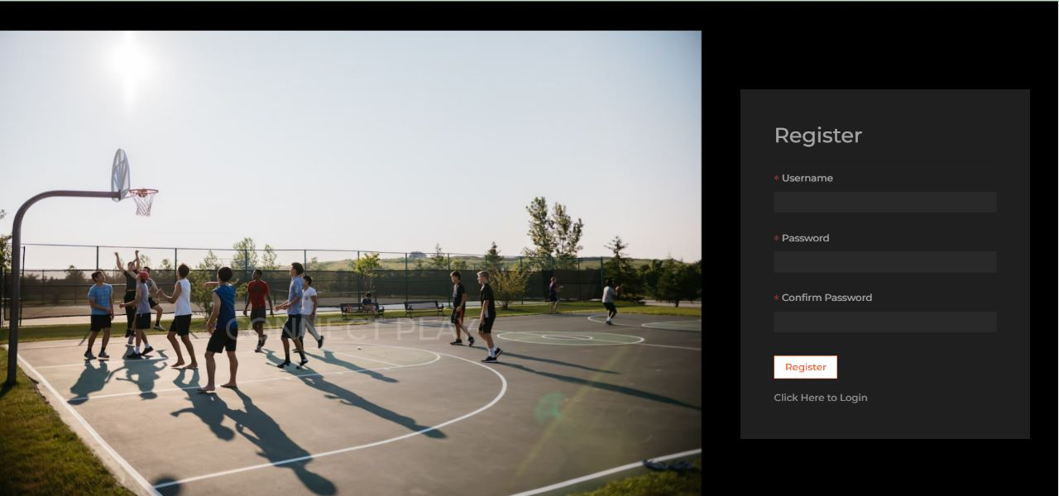

Home Page:

This is the Home Page of our project CONNECTPLAY. After logging in, the user can choose for which type of sport they want to see the available slots or to create their own game.

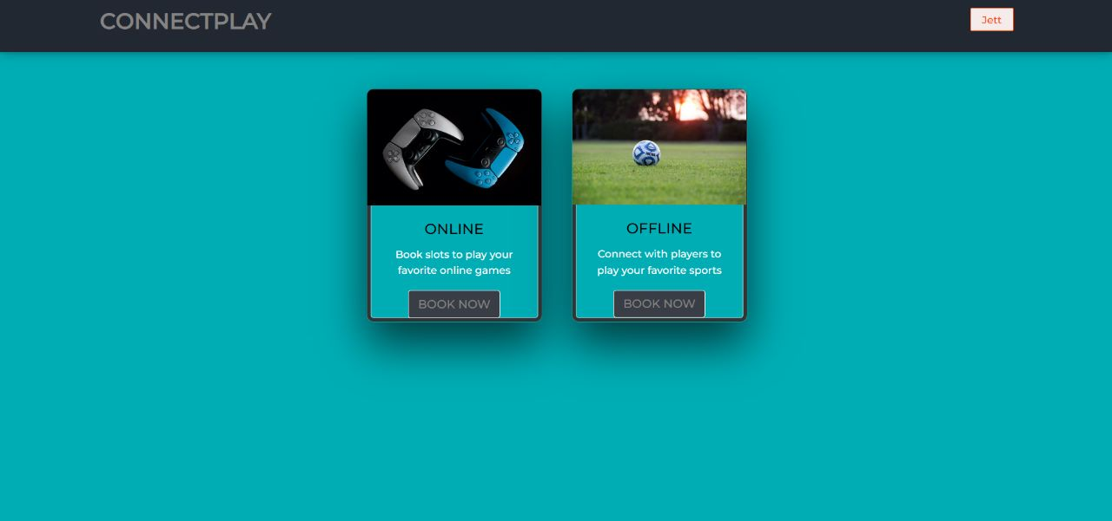

Offline Games Home Page:

This page displays the information about all the available offline games that other admins have already raised requests for. We can choose which game slot we want to book here on this page.

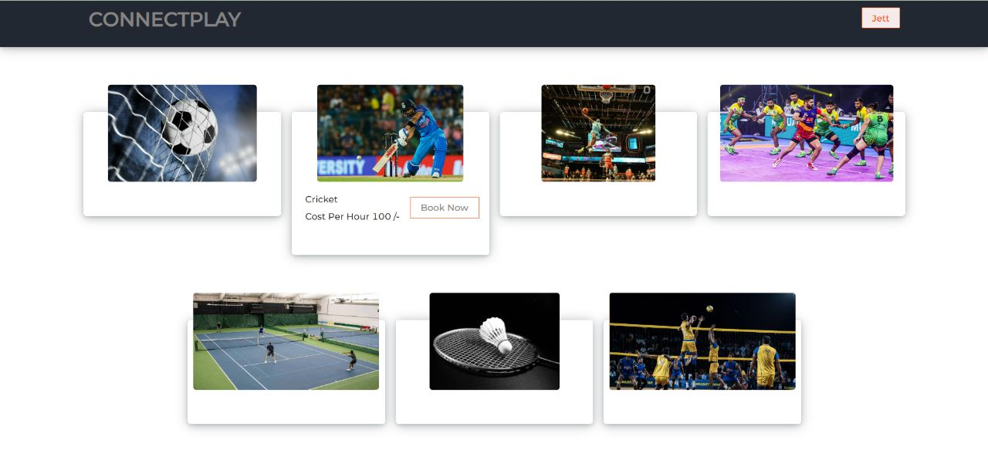

Online Games Page:

This page displays the information about all the available online games that other admins have already raised requests for. We can choose which game slot we want to book here on this page. People with no high-tech gaming hardware can easily play high processor games at cheap costs.

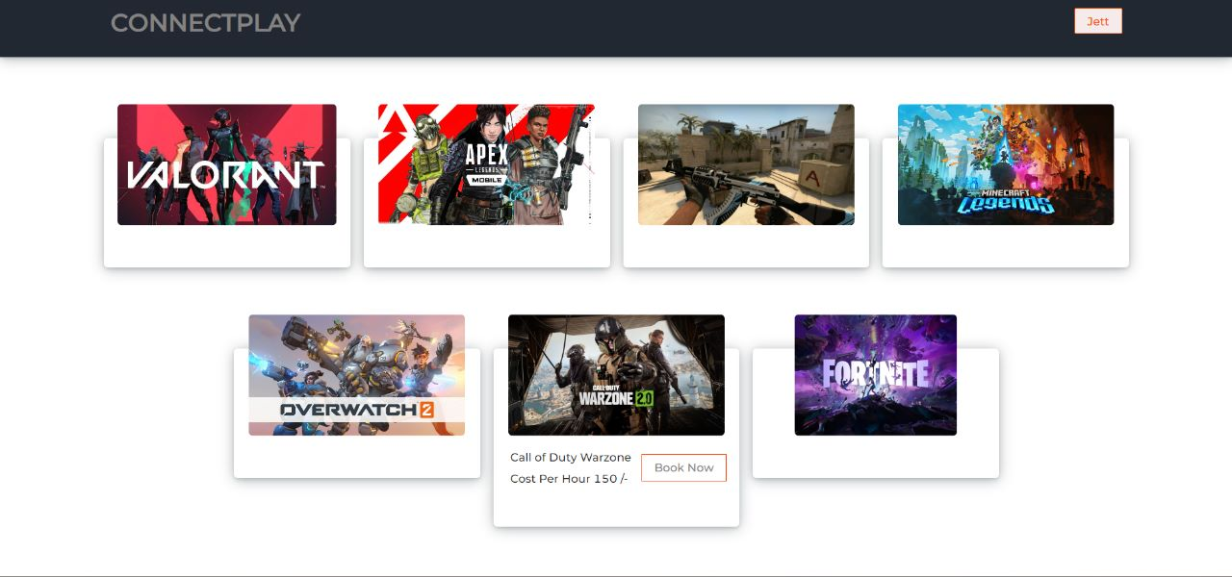

My Bookings Page:

In this page you can check all the bookings you have made. There is a separate my bookings page for both online and offline for the easy accessibility of the user.

Booking Slot Page:

In this page we can select the date and time that we want to play the game. And then we also make the payment here to confirm the slot.

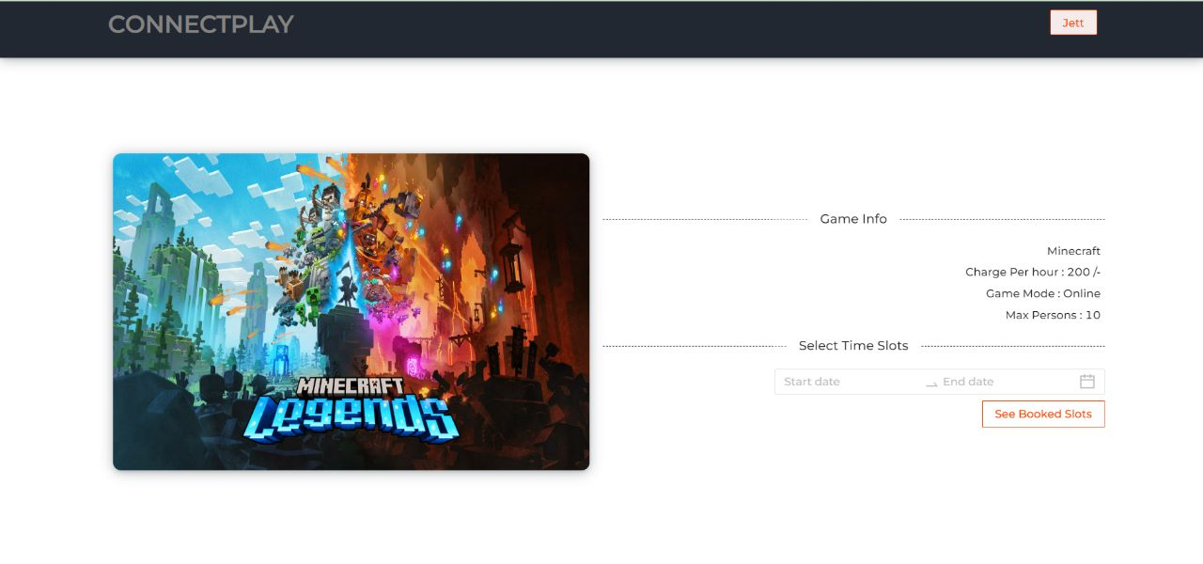

Admin Add/Edit Game Page:

The admins are the ones who raise requests for a game. In the admin access there will be an option to add a new game or to edit an existing one. Once changes are made, it will directly be stored in the database.

**5. CONCLUSION AND FUTURE SCOPE**

* This website makes team sports a great joy again and rekindles friendships. It helps people connect and play in one go.
* It also helps people explore new careers and interests in both outdoor and indoor sports.
* The general market for home-made meals has grown rapidly during COVID when many people were living away from their homes craved for fresh cooked meals and not fast food.

FUTURE SCOPE:

* Since this is a platform-based webpage connecting players, we can always find new ways to improve the UI for users to make it a more friendly and accessible website.
* In the future we can add a Database for the admins to check how many people have already booked for a slot and how many slots are remaining.
* We increase the scope of the project and add full-fledged sporting events that will encourage more people to participate in team sports as well as e-sports.
* Filters based on location and other categorical display of data to find more specific requests.

**BIBLIOGRAPHY**

* <https://youtu.be/oSIv-E60NiU>
* <https://www.w3schools.blog/redux-reactjs>
* <https://www.w3schools.com/bootstrap/>
* <https://youtube.com/playlist?list=PLC3y8-rFHvwgg3vaYJgHGnModB54rxOk3>
* <https://www.ibm.com/support/pages/how-connect-mongodb>
* <https://youtube.com/playlist?list=PLC3y8-rFHvwheJHvseC3I0HuYI2f46oAK>
* <https://morningconsult.com/opinions/youth-sports-are-dying-and-our-kids-need-our-help/>
* <https://www.aspeninstitute.org/blog-posts/7-charts-show-fix-youth-sports/>
* <https://youtu.be/1r-F3FIONl8>
* <https://youtu.be/Oe421EPjeBE>
* <https://www.sclhealth.org/blog/2019/07/the-connection-between-youth-sports-and-success/#:~:text=Instills%20a%20sense%20of%20determination.&text=It's%20also%20probably%20no%20coincidence,participated%20in%20high%20school%20athletics>.